Multiplayer Family Games & Fun
Lego
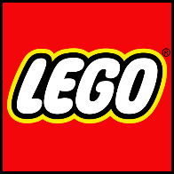
Lego isn’t just for kids! Rediscover the joy together building your own worlds. Don’t forget to enter our raffle on Day 1 of our Winter Wellness Calendar. You could win some fantastic Lego. A massive thanks to Lego for sponsoring this giveaway!

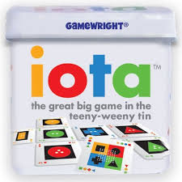
Iota
Tiny Game that packs a punch. Ages 8 and up. This pocket-sized game will test your ability to join cards on a grid based on 1 of 3 similarities (Colour, Shape or Number). Spot patterns to collect points and cut off opportunities for your opponents. Great Fun and a real mind bender. 2 -4 players.

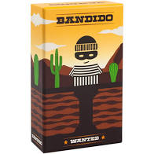
Bandido
A co-operative game where you work together to stop Bandido from tunnelling his way out of Prison. Add cards to build a maze that creates dead ends and loops for Bandido. Play at 2 difficulty levels. Age 6 and up. 1-5 players.

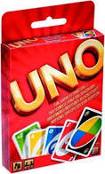
Uno
A classic that is sure to cause a fracas in your home this Christmas. Be the first player to get rid of al your cards, be sure to shout Uno and be careful, your friends may give you an unwanted gift of extra cards just as you’re about to win. 3-8 players. Age 6 and up.

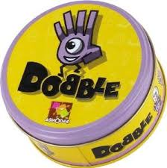
Dobble
This game is like Snap on Steroids. 8 symbols on a card, no matter which 2 cards you choose there is always 1 (and only 1) matching symbol. Shout out the correct answer to win that card. This game is raucous fun and you’ll be amazed at what you miss right under your nose. You can play with as few as two up to as many will fit around the table. This is a great family travel game, comes in a nice tin and is probably the first game you will genuinely lose to a 6 year old.
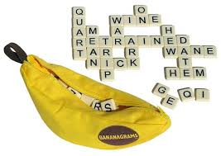
Bananagrams
Think Scrabble but less posh. No board so you can build your grid in whatever direction you like. Be the first to use all your letter tiles in the grid to win. Have a tile left over, throw it back into the bunch, but take 3 more. Pressure is on for everyone aged 8 and up.

Qwirkle
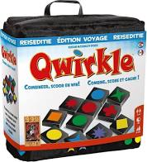
Similar to Iota, add to the grid of wooden tiles to get points. You can match your tiles based on number or shape to build scores in all directions. A really fun game that all the family can join in on aged 6 and up. Available in travel size or full size.

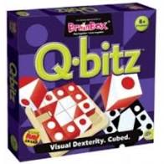
Q-Bitz
A visual dexterity game. Match the pattern on the cube by turning your cubes to the correct side. A frantic fun filled game. If you really want to test yourself, try do it from memory. Play against the clock or up to 4 players. Ages 6 and up

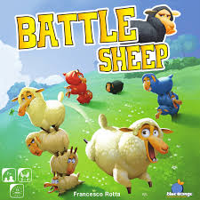
Battle Sheep
Become the most powerful shepherd by spreading you flock across the pastures of this modular board. Stop the other players from spreading their sheep tiles while avoiding getting yours trapped in a corner. A surprisingly tactical games which is totally whacky and great quality. Ages 8 and up. 2-4 players.

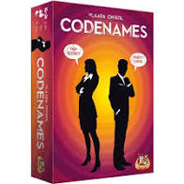
Code Names
Work in teams to crack find all your targets before the opposite team. One member of each team can see all their target words. They are the Codemaster. They can give their team a single word clue to identify as many targets as possible. Play it safe and you’ll only get one target per turn, too ambitious and you may end up choosing the wrong targets. A really clever group game that can be played with 4 or more players. Some abstract thinking involved so suitable for 8 plus.

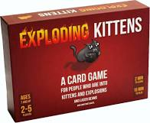
Exploding Kittens
This game was an internet phenomenon for a reason. A lovely mix of skill and luck. Draw cards and try avoid the exploding kitten. Play cards from your hand to make your opponent draw extra cards or to skip your turn. Time it just right to win. Ages 6 plus, 3 or more players.

Pengoloo
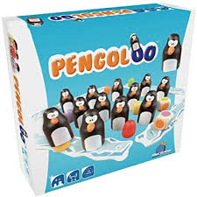
A beautiful wooden memory game that can be played at a number of different levels. 12 wooden penguins hiding 12 colourful eggs. There are 2 of each colour. You can play as a matching game or roll the dice and try find the colour shown. When you find your penguin, bring it onto your iceberg. Most penguins when all are safe wins. Or make it a little more adventurous and keep the penguins that are already found in play. If I find a penguin on your iceberg with my colour egg, I can rob it. Suitable for 4 and up, 2 to 4 players.
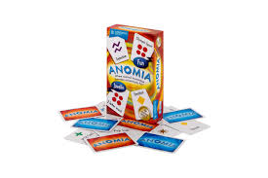
Anomia
An outrageously fun card game that will have simple words stuck on the tip of your tongue. You can play with as many people fit around a table and everyone draws a card in front of them. The car will show a symbol and a simple category. If 2 people get a matching symbol, they go head to head to name something from their opponent’s category first. Its amazing how hard it is to name a vegetable quicker than someone else names an actor. The more players the bigger the chaos. Ages 8 and up. 5 or more players for best results.

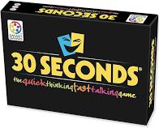
30 Seconds
A game best described as verbal charades. Take a card and get your teammates to say the 5 words on the card in 30 Seconds. You cannot say the words, you cannot say the letters, you must describe the words. Irish themed to make it really feel personal. Available in Junior versions for age 6 and up or Senior versions for 10 and up. 4 or more players.

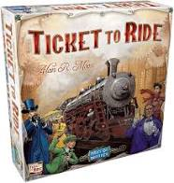
Ticket to Ride
A lovely family strategy game where you try build train routes across either America or Europe. Choose your routes carefully and don’t let anyone know where you’re going or they might try to cut you off. Points are awarded for completed routes with bonuses for longest railway. Points are deducted for uncompleted tickets. Playing time roughly 1 hour. 2 to 5 players. Ages 8 and up.

Klask
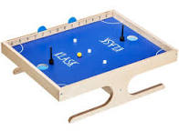
A lovely durable wooden game the feels like miniature air hockey. The players control their magnetic markers from under the table and try score points against the opposition and defend their own goal. Available in 2 or 4 player versions.

